**Create rounded corners**

<http://www.css3.info/preview/rounded-border/>

**Reading**

The CSS3 border-radius property allows web developers to easily utilise rounder corners in their design elements, without the need for corner images or the use of multiple div tags, and is perhaps one of the most talked about aspects of CSS3.

Since first being announced in 2005 the boder-radius property has come to enjoy widespread browser support (although with some discrepancies) and, with relative ease of use, web developers have been quick to make the most of this emerging technology.

Here’s a basic example:

#example1 {

border-radius: 15px;

}

However, for the moment, you’ll also need to use the -moz- prefix to support Firefox (see the browser support section of this article for further details):

#example1 {

-moz-border-radius: 15px;

border-radius: 15px;

}

**How it Works**

Rounder corners can be created independently using the four individual border-*-radius properties (border-bottom-left-radius, border-top-left-radius, etc.) or for all four corners simultaneously using the border-radius shorthand property.

We will firstly deal with the syntax for the individual border-*-radius properties before looking at how the border-radius shorthand property works.

**border-bottom-left-radius, border-bottom-right-radius, border-top-left-radius, border-top-right-radius**

The border-*-radius properties can each accept either one or two values, expressed as a length or a percentage (percentages refer to the corresponding dimensions of the border box).

**The Syntax:**

border-*-*-radius: [ <length> | <%> ] [ <length> | <%> ]?

**Examples:**

border-top-left-radius: 10px 5px;

border-bottom-right-radius: 10% 5%;

border-top-right-radius: 10px;

Where two values are supplied these are used to define, in order, the horizontal and vertical radii of a quarter ellipse, which in turn determines the curvature of the corner of the outer border edge.

Where only one value is supplied, this is used to define both the horizontal and vertical radii equally.

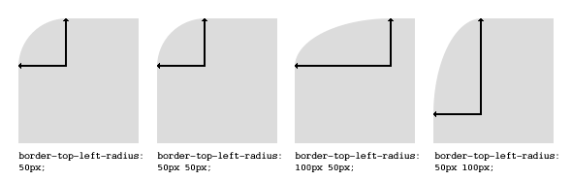

If either value is zero, the corner will be square, not round.

**border-radius**

The border-radius shorthand property can be used to define all four corners simultaneously. The property accepts either one or two sets of values, each consisting of one to four lengths or percentages.

**The Syntax:**

[ <length> | <percentage> ]{1,4} [ / [ <length> | <percentage> ]{1,4} ]?

**Examples:**

border-radius: 5px 10px 5px 10px / 10px 5px 10px 5px;

border-radius: 5px;

border-radius: 5px 10px / 10px;

The first set of (1-4) values define the horizontal radii for all four corners. An optional second set of values, preceded by a ‘/’, define the vertical radii for all four corners. If only one set of values are supplied, these are used to determine both the vertical and horizontal equally.

For each set of values the following applies:

If all four values are supplied, these represent the top-left, top-right, bottom-right and bottom-left radii respectively. If bottom-left is omitted it is the same as top-right, if bottom-right is omitted it is the same as top-left, and if only one value is supplied it is used to set all four radii equally.

**Questions**

What does border-radius property allows?

what is the most talked about aspects of CSS3?

When was announced border-radius property?

Is it an emerging tech nology?

What do you need to support Firefox?

How can Rounder corners be created independently?

Can border-*-radius properties accept one or two value?